The Rosenstrasse protest in Berlin

2nd March 1943:An extraordinary public protest against the detention of Jews in central Berlin causes the Nazis to back track, at least temporarily
MAR 2

SAVE |  | ▷ LISTEN

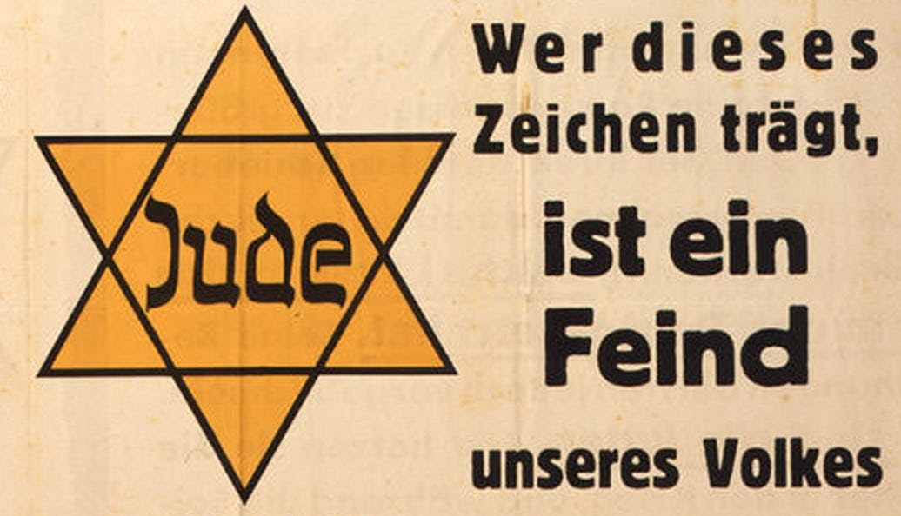
"Whoever wears this sign is an enemy of our people". Jews married to non-Jews were still required to wear the Judenstern.
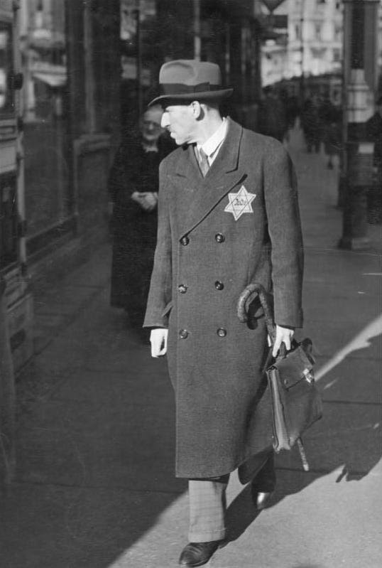
Man with Jewish star, September 1941 (place unknown, possibly Berlin).
The Nazi racial laws which targeted the Jews of Germany for discrimination and eventually murder were not always straightforward to apply. Exceptions were made for Jews who have served in the German military in the First World War, for those who were not wholly of 'Jewish blood' and for those who had been married to non-Jewish 'Aryan' partners before the introduction of the laws. These cases required individual decisions to be made.
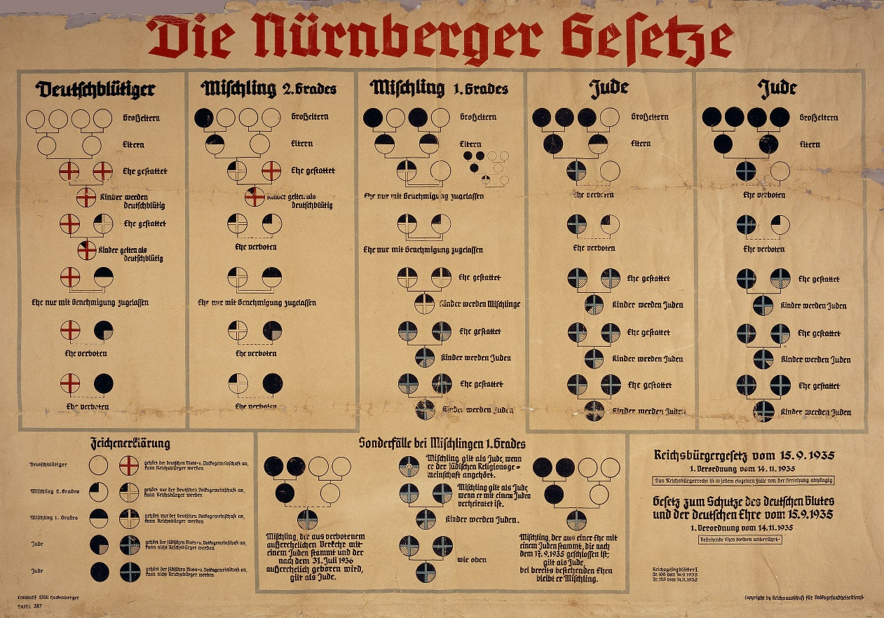
A chart explaining the effect of the 1935 Nuremberg Race Laws. Only people with four non-Jewish German grandparents (four white circles in top row left) were of "German blood". A Jew was defined by the Nazis as someone who descended from three or four Jewish grandparents (black circles in top row right). In the middle stood people of "mixed blood" of the "first or second degree.
I gave the order to the SD [Gestapo], the evacuation of the Jews is not to continue, we need to be more calculating at such a critical time. We can wait a few weeks, then we can carry on more thoroughly.
When the round-up of Berlin Jews started on the 27th February, a large group of men who claimed some form of privilege were separated from those immediately bound for Auschwitz. They were detained at a building in Rose Street in Berlin while they were processed. It did not take long for their relatives to learn of this and a remarkable protest was soon organised.
On the 2nd March the relatives were relieved to discover that the building had not been hit by the latest Allied bombing raid, unlike many buildings nearby. Dr Walter Laqueur¹ was one of those who witnessed the protest:
As I went on, I was suddenly witness a scene I had not experienced in Germany for many years: a spontaneous demonstration, it was the middle of the war in Germany, and here was a small rebellion.
The non-Jewish spouses and children of those arrested had quickly found out what had happened, and began to line up in front of the camp in Rose Street. The first morning, it was just a dozen. They demanded to be allowed to talk to their husbands. Their desire was not fulfilled, but they stayed.
Towards evening, a few hundred camped outside the gate and shouted: "We want to see our men again" and "Give us back our fathers." The next day their numbers grew to about a thousand. They were a considerable scandal, and they sent delegations to nearby police stations and even the headquarters of the Gestapo sent.
The women were desperate, they had nothing to lose, and if there was a massacre of German women in the centre of Berlin, in the middle of the war, what then?
The authorities were amazingly helpful, even polite. There was no cause for alarm, they said, it was still not decided, we'll review the matter again. But the wives were not satisfied with such non-committal drivel: "What needs to be checked?" They wanted to have their men on the spot, immediately ...
When the officials said that the people could not yet be released, the women suggested that they wanted to stay with their husbands in jail. The officials answered that it was not allowed because the men are under arrest. The women replied that Rose Street was not a prison, and they had the right to enter the building. The Fuhrer would certainly not approve of such an unlawful practice ...
The officials did not know what to answer, and turned to their superiors for new instructions. Throughout Berlin, rumors spread that there, right in the city centre is a demonstration, that people had defied the authorities. Some foreign correspondents - from Sweden and Switzerland - cropped up in the neighbourhood. They claimed of course, that this was quite unremarkable, that they were just passing by.
There were also a few police officers were there, but they were trying not to be noticed. From time to time a sedan with a lowered curtain drove by the rallying point. Some senior officials gave advice or issued new instructions.
Part of the crowd moved on to another small road, the Castle Road. They came to a stop outside one of the first houses, a nondescript office building without a badge and logo on the facade and without a neon sign - it was the district headquarters of the Gestapo.
In my life I have seen many sorts of crowds and I know that each one is different ... The crowd this morning was disciplined, but obviously wanted to enforce their rights. It was a lot of people, consisting mainly of women and children, and they knew what they wanted. They chanted... "Give us our husbands back" It was an amazing scene - a scene without precedent.
Poor women, I thought, how long would they be able to keep it up, if the police and the SS show up? The women were desperate, they had nothing to lose, and if there was a massacre of German women in the centre of Berlin, in the middle of the war, what then?
You could not have kept that secret long, and what impression would it have made to the soldiers who fight on the icy fields of Russia? Maybe they had a chance.
Eventually, the men were released on the orders of Goebbels, not out of compassion or because it had been wrong, but because he was dealing with the public reaction to the bombing of Berlin as well. On the 6th March Goebbels recorded in his diary:
There have since unfortunately some unpleasant scenes played in front of a Jewish old people's home, a crowd gathered in a busy central area, some even had a little party for the Jews.
I gave the order to the SD [Gestapo], the evacuation of the Jews is not to continue, we need to be more calculating at such a critical time. We can wait a few weeks, then we can carry on more thoroughly.
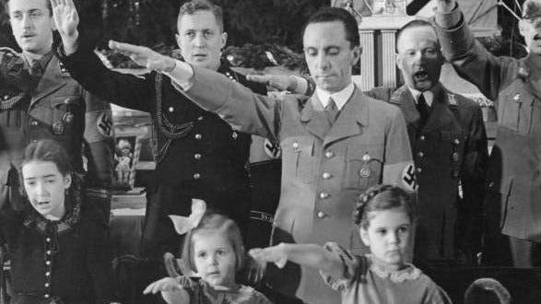
Joseph Goebbels with his daughters, Hilde (center) and Helga, at a Christmas celebration in Berlin, 1937. In 1945 he would murder them rather than allow them to survive the war. Recent research indicates the Goebbels wife’s father was Jewish - so his children would have been ‘Mischling’ under the Nuremberg Laws.
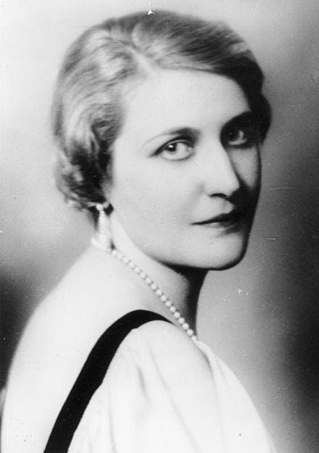
Magda Goebbels (1901-1945), wife of Josef, was the daughter of Auguste Behrend. Some claim that Auguste had an affair with Joseph Friedlander, a Jewish businessman, before she married him in 1908. No father was shown on Magda’s birth certificate but later Friedlander claimed Magda as his daughter on his residency card. Friedlander died in Buchenwald Concentration Camp in 1939, by which time Magda was claiming to be the daughter of Oskar Ritshel, her mother’s first husband.
1
Gernot Jochheim, The Women's Protest in Rose Street. "Give us our husbands back," Berlin Edition Hentrich, 1993, the original is available at Luise-Berlin.de

